Computer Language Coding Concepts

Calling a System Command in a Diagram
A call to a system command can get a complex notation, if you have to show the system interface opened up and then call the system command. Below is an example of a call to an Object . Get system command:

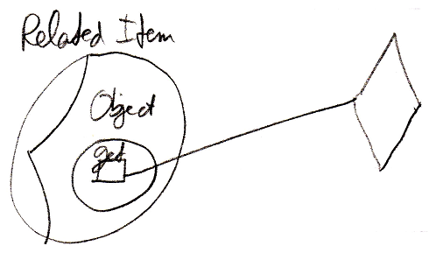

But because a call to a system command is such a basic thing, it gets a simpler notation, like this:

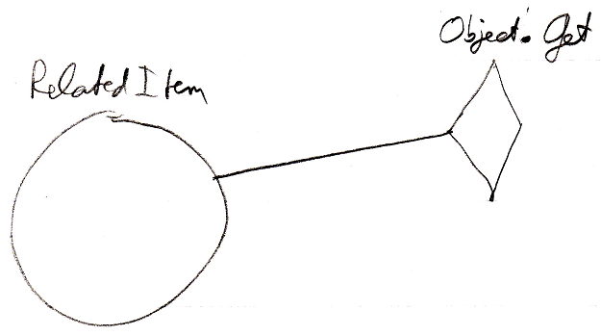

If the call shows the command name (in this case Object . Get), you do not have to show the command definition or the system interface.

That way, a system command looks like a basic command, that you can always execute on any object.

See also: System Objects

Author & Copyright: Jan-Joost van Zon Date: July 24, 2008 – July 24, 2008 Location: Oosterhout, The Netherlands Status: Finished

